ABOUT FILES

One.c- Basics of function +code to multiply two functions using functions

Two.c-

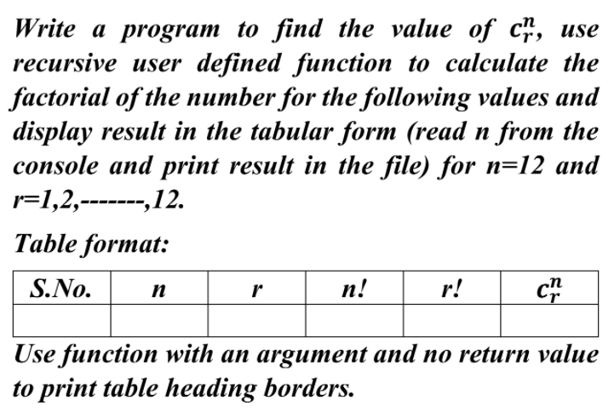

Three.c-

STORAGE CLASS IN C-

1.AUTO ----- AUTO INT X = INT X

SCOPE- LOCAL TO THE FUNCTION IT IS DEFINED

DEFAULT- GARBAGE VALUE

LIFE TIME-UNTIL THE CODE BLOCK

AUTO STORAGE CLASS IS SIMILAR TO LOCAL VARIABLES

2.EXTERNAL STORAGE CLASS

1.THEY ARE SIMILAR TO GLOBAL VARIABLES

SCOPE- ANYWHERE IN THE PROGRAM

DEFAULT- 0

LIFE TIME-UNTIL FULL CODE IS EXECUTED

NOTE- A GLOBAL VARIABLE CAN BE CHANGED BY ANY FUNCTION

INT ADITYA WRITTEN OUTSIDE THE FUNCTIONN TELLS THE COMPILER THAT IS A GLOBAL VARIABLE.

EXTERN KEYWORD IS USED TO TELL C COMPLIER THAT THE VARIABLE IS DEFINED SOMEWHERE ELSE

STATIC

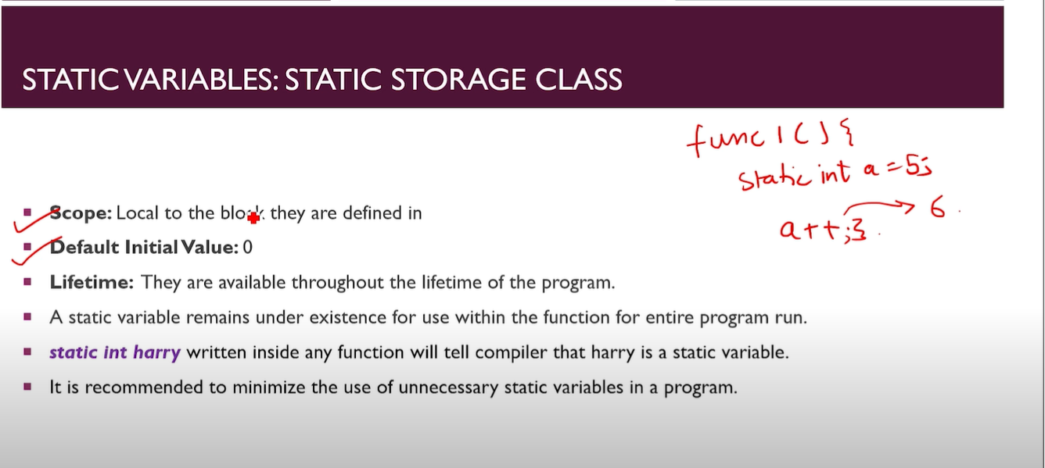

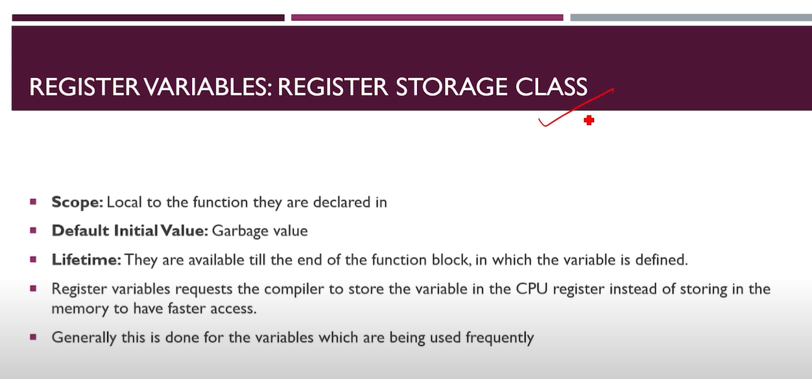

DECALARTION VS DEFINATION

DECALARTION – TELLING THE COMPILER ABOUT VARIABLE NO SPACE IS RESERVED

DEFINATION-DECLARE + MEMORY

Three.c – Local /auto / global

Four.c and five .c -extern key word